A Smart Waste Management System

Phase 1
100 Point
System Requirements Specification

# | Name | ID | Group
1 | Jana Mohamed Tamer | 20245015 | G4
2 | Menna Allah Mostafa | 20245067 | G4
3 | Jana Essam El Deen Hassan | 20246036 | G4
4 | Salma Karim Ahmed Shams | 20245025 | G4
5

Project Team leader email :
20245015@stud.fci-cu.edu.eg
Project Team leader mobile: 01024514660

TA. Mira Mohamed Abdelraheem

Project phase1 SRS should include:
- Purpose:
1.1 Introduction
- The Smart Waste Collection System is a digital platform designed to help municipalities manage garbage collection efficiently and maintain city cleanliness. The system uses smart bins equipped with sensors to measure fill levels. When a bin reaches a predefined threshold, the sensor notifies the central system. Based on this data, the system generates optimized daily routes for drivers, assigns tasks, monitors task completion, and handles penalties if necessary. Supervisors, technicians, and citizens can report or manage complaints through the system, ensuring a clean and well-maintained city.
1.2 System Overview
- 1.2.1 When a smart bin reaches a specific fill level, its sensor sends a notification to the central system.
- 1.2.2 The system then creates daily routes for drivers, showing them which bins they need to empty.
- 1.2.3 Drivers log in to view their assigned bins and confirm after emptying each one. The system checks the sensor reading again.
- 1.2.4 If the bin is still full, the system automatically creates a complaint. Supervisors assign these complaints to technicians to fix.
- 1.2.5 Citizens can also submit complaints if they notice a broken, full, or unclean bin.
1.3 Purpose
- 1.3.1 Improve waste collection efficiency by focusing only on bins that need emptying.
- 1.3.2 Maintain city cleanliness by preventing overflowing bins.
- 1.3.3 Help drivers by giving them clear and optimized daily routes.
- 1.3.4 Automatically detect problems using sensor data to speed up issue resolution.

Scope
2.1 Inside the Scope
The system includes the following functions:
- 2.1.1 Monitoring bin fill levels using smart sensors.
- 2.1.2 Receiving alerts when bins reach the threshold.
- 2.1.3 Generating optimized daily collection routes for drivers.
- 2.1.4 Allowing drivers to log in, view tasks, and confirm emptied bins.
- 2.1.5 Checking sensor readings after confirmation to verify the bin’s status.
- 2.1.6 Automatically creating complaints if the bin is still full after driver confirmation.
- 2.1.7 Allowing citizens to submit complaints about bins.
- 2.1.8 Allowing supervisors to view, manage, and assign complaints to technicians.
- 2.1.9 Allowing technicians to view their assigned complaints, resolve them, and submit reports.
- 2.1.10 Recording penalties when the bin is working correctly but the driver falsely confirms that it was emptied.
2.2 Outside the Scope
The system does not include:
- 2.2.1 Building, installing, or repairing the physical bins or sensors.
- 2.2.2 Handling payments or billing for the municipality.
- 2.2.3 Managing other city services such as water or electricity.
- 2.2.4 Running public awareness or educational programs about waste management.

- Stakeholders:
- Citizens: Report bin issues such as full, broken, or dirty bins.
- Drivers: Receive optimized routes and manage bin-emptying tasks.
- Technicians: Handle technical issues and update maintenance reports.
- Supervisors: Assign complaints, monitor technician performance, and ensure efficient operations.
- System Administrator: Manages user accounts, permissions, and system configurations.

- Abbreviation & Glossary:
- SWMS: Smart Waste Management System
- GPS: Global Positioning System
- UI: User Interface
- Bin Sensor: A device that detects waste fill levels in bins.
- Complaint: A report submitted by a citizen regarding bin-related issues.
- Supervisor: A user responsible for managing drivers, technicians, and complaints.
- Technician: A system user who fixes hardware or sensor issues in the bins.
- Driver: The person responsible for emptying assigned bins according to optimized routes.

- Assumptions and/or constraints:
5.1 Assumptions:
- All smart bins are equipped with functioning sensors that provide accurate fill-level data.
- All system users, including drivers, technicians, supervisors, and citizens, have access to compatible devices and internet connectivity.
- Drivers follow the system-assigned routes and provide truthful confirmation of completed tasks.
- Citizens submit complaints accurately and responsibly.
- Technicians and supervisors are available to address complaints and maintain efficient operations.
5.2 Constraints
- The system is limited by the maximum number of smart bins it can monitor based on database and infrastructure capacity.
- Updates to bin statuses and route generation must occur within a maximum of 5 seconds to ensure timely operations.
- Secure authentication is required for all users, and access to system functions is restricted based on user roles.
- Penalties are applied only if a bin is confirmed to be functioning and has not been emptied by the driver.
- The system cannot physically repair or maintain bins or sensors; it is limited to monitoring, reporting, and workflow management.
- All data storage and processing must comply with relevant privacy and data protection regulations.
- The system must maintain high availability, operating continuously with minimal downtime.

- User requirements:

10.1 Citizen Requirements
- Citizens must be able to log in securely.
- Citizens can submit complaints about broken, full, or unclean bins.
- Citizens can view the status of their submitted complaints (Pending, Assigned, Resolved, Rejected).
- The system should notify citizens when their complaints are resolved.

10.2 Driver Requirements
- Drivers must be able to log in securely.
- Drivers can view their assigned daily route and the bins they need to empty.
- Drivers can confirm when a bin has been emptied.
- The system should automatically verify bin status using sensors after confirmation.
- Drivers are notified if a penalty is applied due to unemptied bins.
- The interface should be simple and easy to use while on the route.

10.3 Supervisor Requirements
- Supervisors must log in securely to access their dashboard.
- Supervisors can view all complaints submitted by citizens or generated by the system.
- Supervisors can assign complaints to technicians efficiently.
- Supervisors can monitor driver performance, including penalties and task completion.
- Supervisors can generate reports on bin statuses, driver tasks, and complaint resolutions.

10.4 Technician Requirements
- Technicians must log in securely to access assigned tasks.
- Technicians can view complaints assigned to them with all relevant details.
- Technicians can update complaints as resolved and submit resolution reports.
- Technicians can log observations and actions taken to resolve bin issues.

7. System Requirements
7.1 Functional Requirements

7.1.1 Bin Monitoring
- The system shall receive fill-level data from all smart bins in real time.
- The system shall store and update the latest status for each bin.
- The system shall notify the central system and relevant users when a bin reaches the predefined threshold.

7.1.2 Route Management
- The system shall generate optimized daily routes for drivers based on bins that need emptying.
- The system shall assign routes to drivers and allow them to view their assigned bins for the day.

7.1.3 Driver Task Management
- The system shall allow drivers to log in securely.
- The system shall allow drivers to confirm when a bin has been emptied.
- The system shall verify each bin’s status using sensor readings after driver confirmation.
- The system shall automatically generate a complaint if a bin remains full.
- The system shall record a penalty if the bin is functioning correctly but the driver did not empty it.

7.1.4 Complaint Management
- The system shall allow citizens to submit complaints about broken, full, or unclean bins.
- The system shall store complaints and track their status (Pending, Assigned, Resolved, Rejected).
- The system shall allow supervisors to view all complaints and assign them to technicians.
- The system shall allow technicians to resolve complaints and submit resolution reports.

7.1.5 Authentication and Access Control
- The system shall allow all users to log in with valid credentials.
- The system shall restrict access to functions based on user roles (Citizen, Driver, Supervisor, Technician).

7.1.6 Reporting and Audit
- The system shall log all user actions (logins, task confirmations, complaint updates) with timestamps.
- The system shall allow supervisors to generate reports on driver performance, bin statuses, and complaint resolutions.

7.2 Non-Functional Requirements
These requirements describe the quality and performance features of the Smart Waste Management System rather than its functions.

7.2.1 Usability
- The system shall have a simple and easy-to-use interface for all users.
- Buttons, labels, and instructions shall be clear and written in plain language.
- Each user (Citizen, Driver, Technician, Supervisor) shall see only the options relevant to their role.
- Error and success messages shall be clear and user-friendly (e.g., "Bin updated successfully", "Invalid login, please try again").
- Users shall be able to complete main tasks without special training.

7.2.2 Reliability
- The system shall correctly handle sensor data and update bin status without data loss.
- The system shall remain operational even if one or more sensors temporarily stop sending data.
- Tasks and complaints shall not be lost in case of temporary system failures.

7.2.3 Performance
- The system shall process and display new bin or complaint information within 5 seconds.
- Route generation for drivers shall complete within a few seconds after sensor updates.
- Drivers shall be able to load their daily route in under 2 seconds.

7.2.4 Security
- All users shall log in with a valid username and password.
- Only authorized users shall access functions allowed for their role.
- Sensitive data shall be stored securely (password hashing, encryption).
- Supervisors and technicians shall only access data relevant to their responsibilities.

7.2.5 Availability
- The system shall be available 24/7 for monitoring and citizen complaints.
- Main operational features shall be available during working hours.
- Notifications from sensors shall be processed immediately when received.

7.2.6 Maintainability
- The system shall be modular and well-documented for easy updates.
- The database shall support adding new users, bins, and roles without major redesign.

7.2.7 Scalability
- The system shall support increasing numbers of bins, drivers, and cities without performance issues.
- Route generation and notifications shall scale automatically as the city grows.

8) Case diagrams
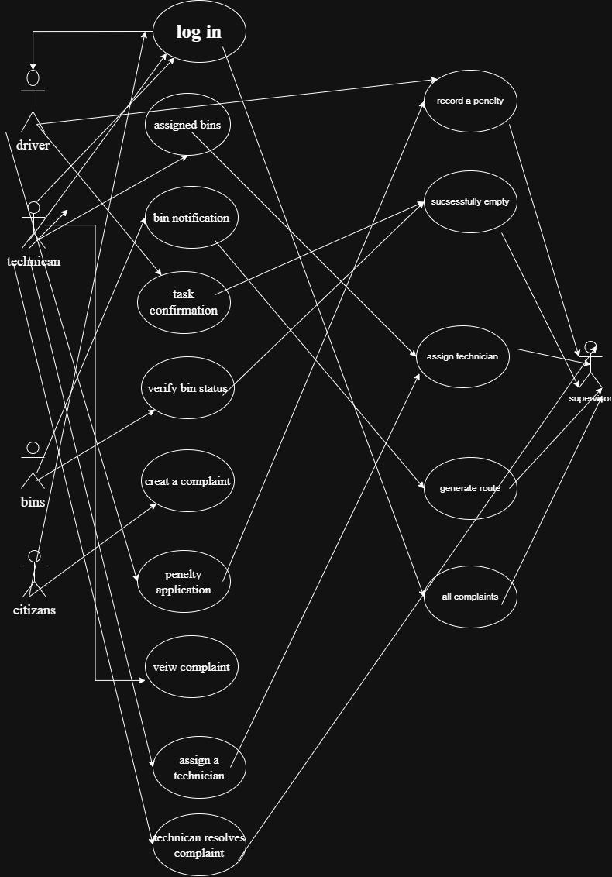

9) Case tables
Use Case ID | Use Case Name | Actors | Description | Preconditions | Postconditions
UC-01 | Log in | All users | User log in securely |  | User successfully logged in and redirected to dashboard
  User has valid credentials
UC-02 | View assigned route & bins | Driver | Driver views tasks for the day | Driver is logged in | System displays optimized route and assigned bins
UC-03 | Bin Monitoring / Notification | System | Sensor detects predefined fill level | Sensor detects predefined fill level | Notification sent and bin status updated
UC-04 |  | Driver | Driver confirms emptying of a bin | Driver is logged in and selects a bin | System updates bin status in central system
  Task Completion Confirmation
UC-05 | Verify Bin Status | System | System checks sensor reading | Driver confirmed bin emptying | System confirms bin empty or generates complaint if full
UC-06 | Create Complaint Automatically | Citizen | Citizen reports a problem | Citizen is logged in | Complaint recorded for supervisor action
UC-07 | Penalty Application | System | Apply penalty if driver fails task | Complaint verified, bin functioning | Penalty recorded
UC-08 |  | Supervisor | View all complaints and status | Supervisor logged in | Complaint list displayed
  Supervisor Views Complaints
UC-09 | Assign Technician |  | Assign complaint to technician | Complaints pending | Technician assigned
  Supervisor
UC-010 | Technician Resolves Complaint | Technician | Resolve issue and submit report | Technician logged in, complaint assigned | Complaint status updated to Resolved

10) Acceptance Tests Plan

FR ID | Functional Requirement | Test ID | Description | Inputs / Preconditions | Expected Output
UC-01 | Log in | T1 | Allows users to authenticate and access their assigned tasks | User has valid credentials
  User successfully logs in; role-based dashboard displayed
UC-02 | View Assigned Bins / Route | T2 | Displays the optimal route and list of bins assigned to the driver. | Driver is logged in | Driver views tasks for the day.
UC-03 | Bin Monitoring | T3 | System receives data and notofies the central system when bins reach full capacity | Sensor detects predefined fill level | Central systems receives notification ; bin status updated
UC-04 | Confirm Emptying | T4 | Driver confirms that a bin has been emptied | Driver logged in; selects a bin | Bin status updated; system records task completion
UC-05 | Task Verification & Penalty | T5 | System verifies bin status; applies penalty if driver fails | Driver confirmed task; bin still full; bin functioning | Task verified; penalty recorded if driver failed task
UC-06 | Automatic Complaint Creation | T6 | System creates complaint if bin remains full after driver confirmation | Bin status verified after task confirmation | Complaint recorded with Pending status
UC-07 | Citizen Submits Complaint | T7 |  | Citizen logged in | Complaint saved with Pending status
  Citizen submits complaint about broken, full, or unclean bin
UC-08 | Supervisor Views Complaints | T8 | Supervisor views all complaints in the system | Supervisor logged in
  Complaint list displayed, filterable by status
UC-09 | Supervisor Assigns Technician | T9 | Supervisor assigns a complaint to a technician | Supervisor logged in; complaint pending | Complaint assigned; technician notified
UC-10 |  | T10 | Technician resolves complaint and submits resolution report | Technician logged in; complaint assigned | Complaint status updated to Resolved; report logged
  Technician resolves complaint

Class Diagram

2. Sequence Diagram (25 points)

3. Activity Diagram (25 points)

4. State transition Diagram ( 20 points)

5. Validation against Acceptance Testing Plan (10 points)
Review all diagrams and models created in Phase 2, and ensure that each test from the Acceptance Tests defined in Phase 1 is correctly represented.

system Architecture – 3 Layer Architecture
The Smart Waste Collection System follows a 3-Layer Architecture, to ensure clear separation of responsibilities and ease of maintenance.

Layer 1: Presentation Layer
The Presentation Layer represents the user interface of the system. It is responsible for interacting with users and displaying information.
Responsibilities:
- Display login screens and dashboards.
- Allow users to submit inputs such as complaints or task confirmations.
- Show routes, bin status, and complaint status to users.
- Display success and error messages.
Users interacting with this layer:
- Citizens
- Drivers
- Technicians
- Supervisors
This layer does not contain any business logic or data storage. It only forwards user requests to the Logic Layer and displays the returned results.

Layer 2: Logic Layer (Business Logic Layer)
The Logic Layer contains the core business logic of the system and acts as the brain of the application.
Responsibilities:
- Process user requests received from the Presentation Layer.
- Handle bin monitoring and sensor notifications.
- Generate optimized daily routes for drivers.
- Verify bin emptying after driver confirmation.
- Automatically create complaints when issues are detected.
- Apply penalties to drivers when required.
- Manage complaint assignment and resolution.
This layer communicates with both the Presentation Layer and the Data Layer but does not handle direct user interaction or data storage.

Layer 3: Data Layer (database layer)
The Data Layer is responsible for storing and retrieving system data.
Responsibilities:
- Store user information.
- Save bin status and sensor readings.
- Store complaints and their statuses.
- Record penalties and routes.
- Retrieve data requested by the Logic Layer.
This layer contains only data access operations and does not include business rules or user interface logic
Architectural diagram

Class diagram:

Traceability Table

Requirement ID | Requirement Description | Use Case ID | Component / Class | Test Case ID
FR-7.1.5 | User authentication and role-based access | UC-01 | User, System | AT-01
FR-7.1.2 | Driver views assigned route and bins | UC-02 | Driver, Route, Smartbin,gps | AT-02
FR-7.1.1 | Bin monitoring and notification on threshold | UC-03 | Sensorinterface, Smartbin,system | AT-03
FR-7.1.4 | Citizens can submit complaints | UC-06 | Citizen, Complaint | AT-06
FR-7.1.2 | Generate optimized routes | UC-02 | Route, System,gps | AT-02
FR-7.1.3 | Verify bin status after confirmation | UC-05 | SensorInterface, SmartBin, System | AT-05
FR-7.1.3 | Driver confirms bin emptied | UC-04 | Driver, SmartBin | AT-04
FR-7.1.3 | Automatic complaint creation | UC-06 | Complaint, System | AT-06
FR-7.1.3 | Penalty applied if driver fails task | UC-07 | Penalty, Driver, System | AT-07
FR-7.1.4 | Supervisor views complaints | UC-08 | Supervisor, Complaint | AT-08
FR-7.1.4 | Supervisor assigns complaint to technician | UC-09 | Supervisor, Technician, Complaint | AT-09
FR-7.1.4 | Technician resolves complaint and submits report | UC-10 | Technician, Report, Complaint | AT-10

Application of SOLID Principles in the Smart Waste Management System

a) What changes did you do to your class diagrams to respect SOLID principles in the design phase?
During the design phase, the class diagram was refined to comply with the SOLID principles, ensuring the system is modular, extensible, and maintainable.

1. Single Responsibility Principle (SRP)
Each class was redesigned to have one clear responsibility:
- SmartBin → stores bin data and fill level only
- SensorInterface → handles sensor data reading and notifications
- Route → manages route generation and route data
- GPS → provides location and distance calculations
- Complaint → manages complaint details and status
- Penalty → handles penalty information and application
- Report → generates and stores reports
- System → coordinates interactions between components
This separation avoids “god classes” and ensures that changes in one responsibility (e.g., sensor behavior) do not affect others.

2. Open/Closed Principle (OCP)
The system was designed to allow extension without modifying existing classes:
- New complaint types can be added without changing the Complaint class structure.
- Route optimization logic can be enhanced by extending Route or GPS behavior.
- New user roles or system features can be added without altering core classes.
This ensures future scalability while keeping existing code stable.

3. Liskov Substitution Principle (LSP)
User roles (Citizen, Driver, Supervisor, Technician) were designed to behave consistently within system operations:
- Each role interacts with the System without breaking expected behavior.
- Role-specific actions extend functionality rather than altering core logic.
This guarantees that role-based substitutions do not introduce incorrect behavior.

4. Interface Segregation Principle (ISP)
Large, general-purpose interfaces were avoided:
- SensorInterface exposes only sensor-related operations.
- Each user role interacts only with methods relevant to its tasks.
This reduces unnecessary dependencies and improves clarity and maintainability.

5. Dependency Inversion Principle (DIP)
High-level modules depend on abstractions rather than concrete implementations:
- System depends on SensorInterface instead of directly interacting with sensor hardware.
- This allows sensor implementations to change without affecting system logic.
This design improves flexibility and testability.

b) How did you reduce complexity and maintain abstraction in your system design?

1. Separation of Concerns
The system was divided into logical layers:
- Monitoring: SensorInterface, SmartBin
- Routing: Route, GPS
- User Roles: Citizen, Driver, Supervisor, Technician
- Management: Complaint, Penalty, Report
- Coordination: System
Each layer focuses on a specific concern, reducing complexity.

2. Central Coordination Through the System Class
The System class acts as a controller that:
- Manages workflows (routing, complaints, penalties)
- Prevents direct coupling between components
This keeps individual classes simple and focused.

3. Use of Abstraction
- Sensor communication is abstracted using SensorInterface.
- Routing complexity is hidden behind Route and GPS.
Users and higher-level components interact with simple interfaces rather than complex logic.

4. Modular and Testable Design
Each module can be tested independently:
- Sensor data processing
- Route generation
- Complaint handling
- Penalty application
This supports partial implementation and unit testing required in Phase 3.

Conclusion
By applying SOLID principles and abstraction techniques, the system design achieves:
- Reduced complexity
- High maintainability
- Easy extensibility
- Clear mapping between requirements, design, and implementation
This results in a robust and scalable Smart Waste Management System design.

->Small note to TA Mira:
We would like to sincerely thank you for your guidance and support throughout the semester in both Software Engineering and Statistics II. It was truly a pleasure being your students and learning from your experience and dedication
Thank you for everything, and we wish you all the best ❤️❤️❤️

